**Answer1**: Class name is “Answer1”. Screenshot captured is in the “Snap” folder.

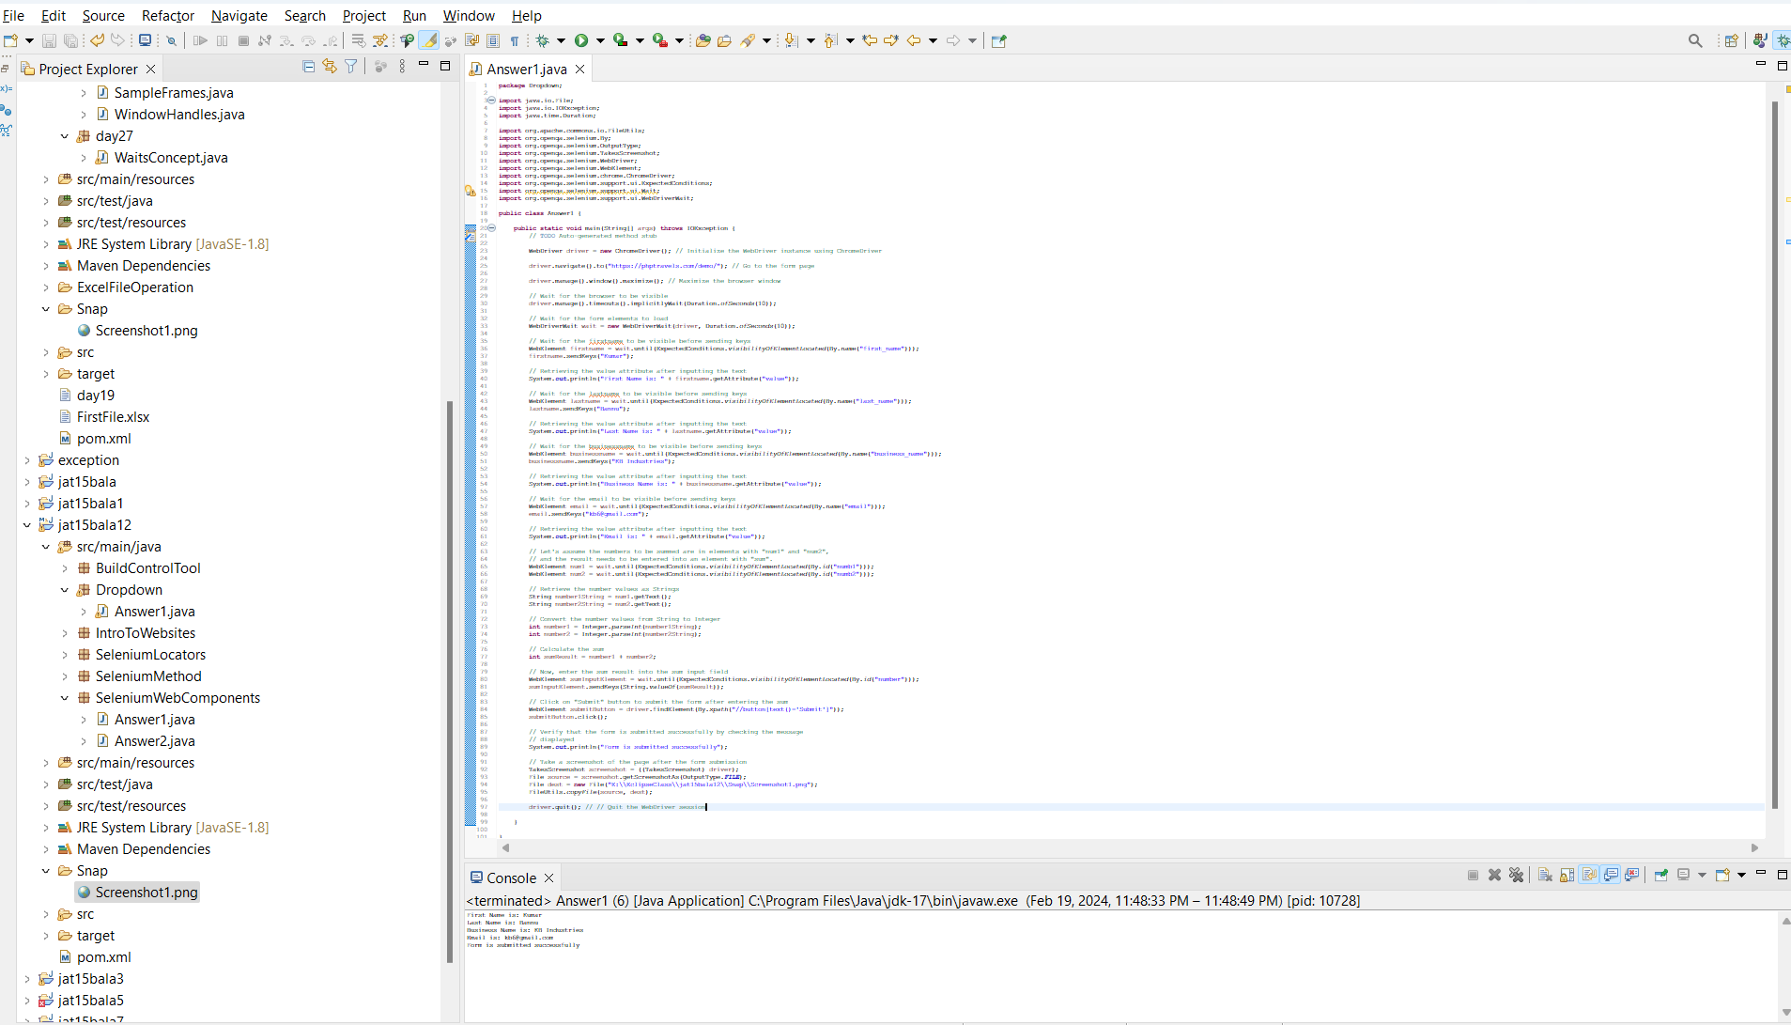

Output Screenshot:

